Customized ISPF Edit Clipboard by Lionel B. Dyck

Contents

Overview 1

SETCLIP – Clipboard Manager 2

Usage Notes 2

SetClip – ISPF Startup 3

# Overview

The IBM ISPF Edit environment supports a clipboard to hold information much like the clipboard on a PC. Within ISPF Edit the clipboard environment supports up to 10 unique clipboards that can be referenced by name in addition to the default clipboard.

Setting up the clipboards for use can be a tedious process and requires each user to manually do it when they need them.

A new ISPF application, SETCLIP, is now available that greatly simplifies the establishment of multiple clipboards by:

* Provides the ability to define from 1 to 10 unique clipboards by name using a simple ISPF dialog
* Each clipboard is defined by name and is related to a specific dataset or dataset member
* Creates the clipboards when the dialog ends
* Optional ability to create the clipboards when ISPF Starts

Before using SETCLIP be sure to use the EDSET Editor command to make sure that the default actions for CUT is REPLACE and for PASTE is KEEP.

# SETCLIP – Clipboard Manager

The SetClip application is invoked from the ISPF Command line as **TSO %SETCLIP**.

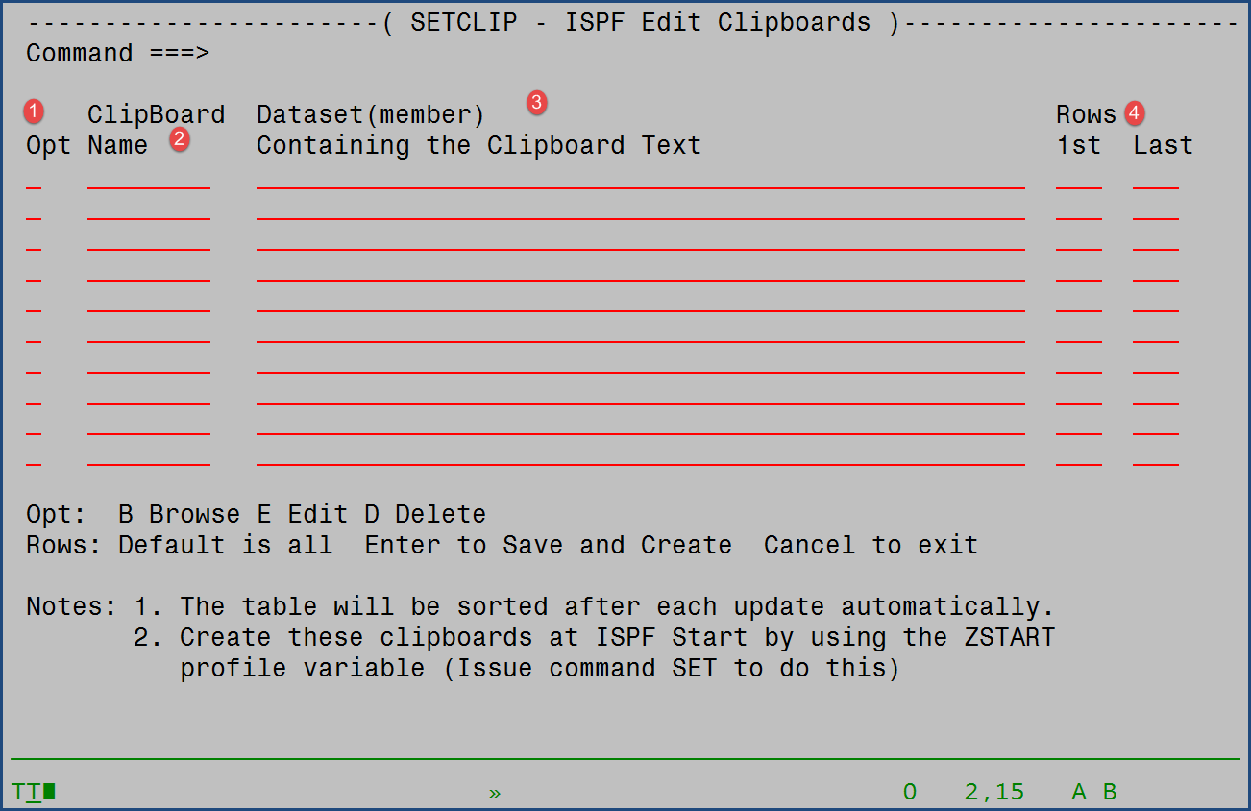

There are three key sections of the panel:

1. The option for the specific line. The supported options are: B (Browse), E (Edit), and D (Delete).
2. ClipBoard Name is the name to be assigned to the clipboard. It must conform to the same naming conventions as a PDS Member. This field can be over-typed to change an existing name as well.
3. Dataset(member) is the dataset or dataset(member) that contains the text to be copied into the clipboard.
4. Rows defaults to all records. Either the first row number, or the last row number, or both may be defined to limit the records copied into the clipboard.

Once setup use PF3 to exit the application and save the updates to the clipboard(s). Upon exit the clipboards will also be created and become available, until ISPF exits, to any ISPF Edit session.

## Usage Notes

1. Clipboard names of X and NX are not allowed as those are keywords on the CUT command.
2. Rows with a Clipboard name and no dataset will be flagged as errors.
3. Rows with no Clipboard name but having a dataset will be flagged as errors.

# SetClip – ISPF Startup

SetClip is also enabled to be invoked at ISPF Startup by using the syntax: **TSO %SETCLIP X**. The X, or any non-blank character, instructs SetClip to read the ISPF Profile variables that contain the clipboard name and dataset and to create the defined clipboards.

This capability can easily be incorporated into the ISPF ZSTART variable which contains ISPF commands that are executed each time ISPF is started.

To update the ISPF ZSTART varible, while in the SETCLIP application issue the **SET** command. This will create, or update, the ZSTART variable.